Mindfulness activities

Concept: Mindfulness for emotional wellbeing
Mindfulness is about focusing attention on the present, rather than focussing on the future.​
Research shows that mindfulness:​
- Increases self-awareness, social awareness, and self-confidence​
- Increases emotional self-regulation​
- Reduces the severity of depression, anxiety and ADHD​
- Builds resilience.

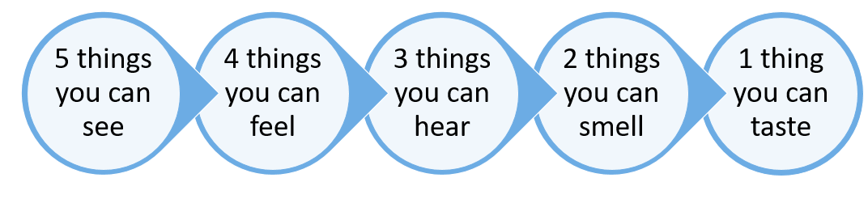
Five senses exercise
All you need to do is to notice something you are experiencing with each of the five senses.​

Notice five things that you can see.​
Look around you and bring your attention to five things that you can see. Pick something that you don’t normally notice, like a shadow or a small crack in the concrete.​

Notice four things that you can feel.​
Bring awareness to four things that you are currently feeling, like the texture of your pants, the feeling of the breeze on your skin, or the smooth surface of a table you are resting your hands on.​

Notice three things you can hear.​
Take a moment to listen, and note three things that you hear in the background. This can be the chirp of a bird, the hum of the refrigerator, or the faint sounds of traffic from a nearby road.​

Notice two things you can smell.​
Bring your awareness to smells that you usually filter out, whether they’re pleasant or unpleasant. Perhaps the breeze is carrying a whiff of pine trees if you’re outside, or the smell of a fast food restaurant across the street.​

Notice one thing you can taste.​
Focus on one thing that you can taste right now, in this moment. You can take a sip of a drink, chew a piece of gum, eat something, or just notice the current taste in your mouth or open your mouth to search the air for a taste.​

