Mindfulness activities

Concept: Mindfulness for emotional wellbeing
Mindfulness is about focusing attention on the present, rather than focusing on the future.​
Research shows that mindfulness:​
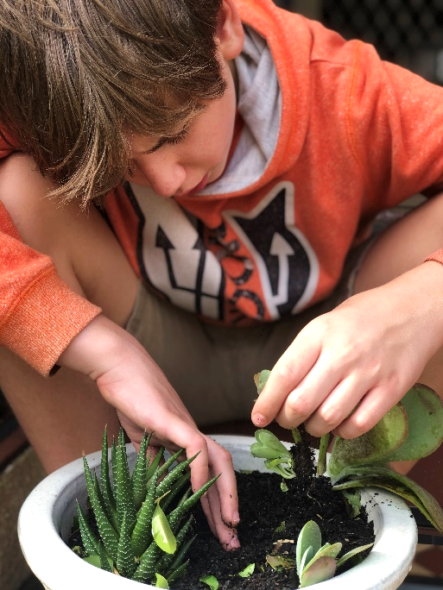
- Increases self-awareness, social awareness, and self-confidence​
- Increases emotional self-regulation​
- Reduces the severity of depression, anxiety and ADHD​
- Builds resilience.

Your backyard or balcony can become a place for you to practice quiet reflection and focus your thoughts.

Try some of the following activities:
- Gardening: plant herbs or do some weeding. Think about the texture of the soil and each plant you touch.

- Sun meditation: Close your eyes and think about the warmth of the sun and the feeling of the sun’s rays on your skin. Allow the warmth to spread to your muscles, joints and bones. Think about the journey the light and heat have made to come and warm you. Think about the glowing energy of the sun.

- Eat something mindfully. Before you start, look at what you’re eating. Think about its shape and colours. What does it smell like? Chew it slowly, thinking about how it feels in your mouth and what it tastes like. What does your chewing sound like? When you swallow the food, can you feel it moving down into your stomach?

- Mindful breathing: Close your eyes and think about your breathing. Breathe in through your mouth and out of your nose. Can you feel the air coming into your mouth? Can you feel it coming out of your nose? What does it feel like? Can you feel the rise and fall of your chest or stomach? If you can’t feel anything, place your hand on your stomach and notice how your hand gently rises and falls with your breath. Remind yourself that trees release the oxygen we inhale and absorb the carbon dioxide we exhale. As we breathe, we are borrowing air before returning it to nature.

- Blowing Bubbles: Notice their shapes, textures and colours.

- Colouring: Colour something. Focus on the colours and designs.

- Listening to Music: Focus on the sound of just one instrument – the drums is a great one to start with.

- Squeeze Muscles: Starting at your toes, pick one muscle and squeeze it tight. Count to five. Release, and notice how your body changes. Repeat exercise moving up your body.

